School of Cachecata
Cachecata is a beautiful little school near Ollantaytambo, in the country site.
This school was about to close it is because of its very basic and poor infrastructure.
Our organization have done a lot projects in this school

Kitchen for the school
Many of those children come from far away to assist to the school in Cachecata
We had set up a kitchen in the school to improve the nutrition of the children
In the school the children get delicious healthy breakfast and lunch
Many of the product that they use to cook the food come from our farm

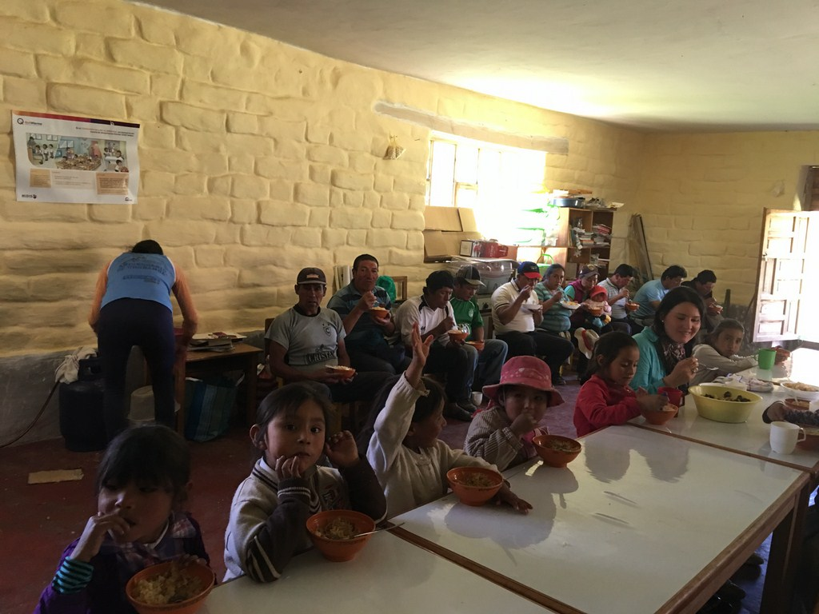

New classroom for the children of Cachecata

One of the most important project at the Cachecata school was to rebuild one of the classroom, now the children are enjoying a new beautiful classroom,

It was a lot work; we had to open a new road to take the materials like sand, concrete etc,

We had small celebration for all the people who helped; the children were hugging each other, they we so happy.

Also, there was a dentist who came to teach the children how to protect their teeth, we have a beautiful lunch and some games.
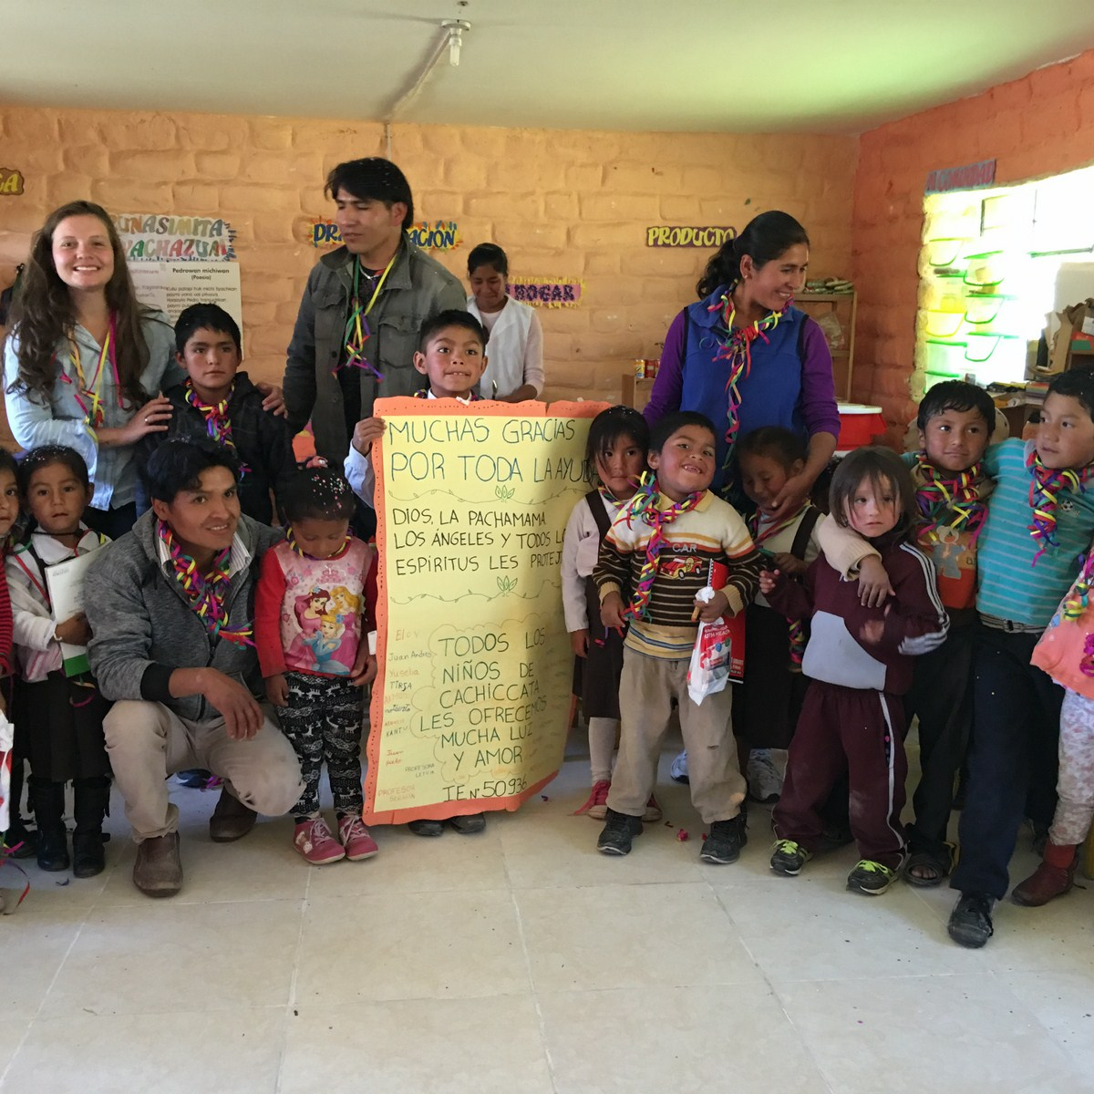

New library for the children of Cachecata
You might would like to know that we had finished with another project; we set up a library for the school of Ccachecata in the Andes of Peru.
The teachers, the parents and all the students were so happy, so they organized a celebration for the opening of the library, there children danced so beautiful.
Attached I’m sending you some pictures of the celebration, I hope you enjoy them; all of these was thanks to you and angel earth like you
We all are sending love and gratitude
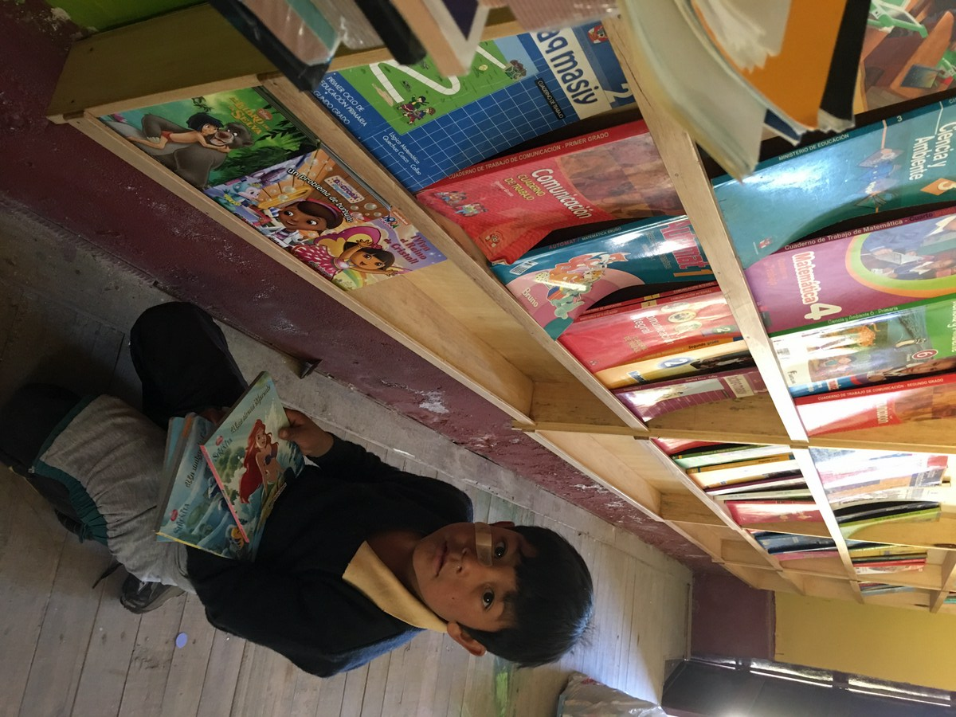

Visiting the sacred places with the children of Cachecata
Thanks for your willing on supporting this project
Those are the children of Ccachecata, we took them to the sacred places of Tambomachay and Sacsayhuman they love, and we have medication.
We have lunch around Sacsayhuman then we visited the city of Cusco and visit some museums there.
The children loved to know all those sacred places and learn about our culture.
Warm hug from Peru

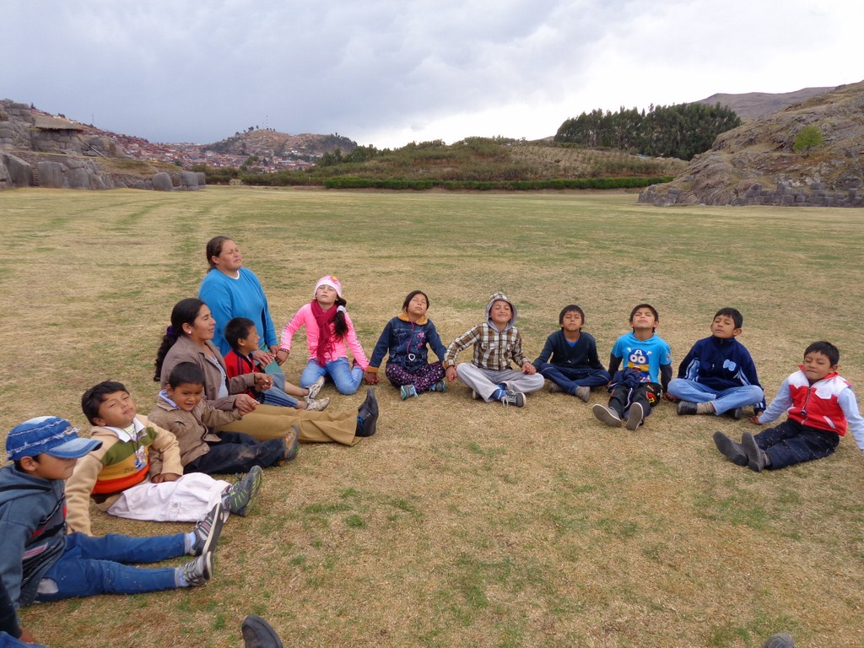

Shoes for the children of Cachecata
Thanks very much for your donation
Those are the pictures when we give the shoes to the children of Cachecata, that was thanks to angels like you.
The children were so happy so they start dancing
Warm hug from all the children from the mountains of the Sacred Valley

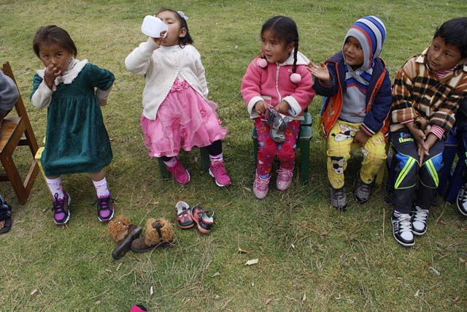

Baby chickens for the mothers, each mother receive an amount of little chickens, when chickens start laying eggs, the mothers have bring the eggs back to the school to feed the children.
