Scholarship for smart children

It is school time once again for our students in Peru. It is Carlos’ and my prayer that you will continue, once again this year, to support the child or children that you so generously supported last year. You will be pleased to know that each of your Paskay children are at the top of their class!!

The children have hopes and dreams of higher education in order to help their families as well as their communities to better prosper.

We are happy to have you as a member of this worldwide family, and we can help each other to create a rainbow energetic connection to share all the heart feelings and good ideas to make Pachamama a warm place to live.

“Pachamama hold you in her warm hands as her beloved child”

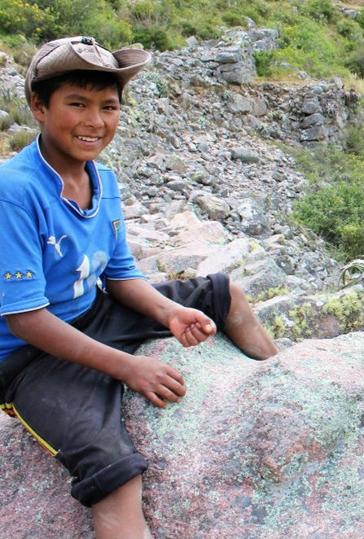
Johan
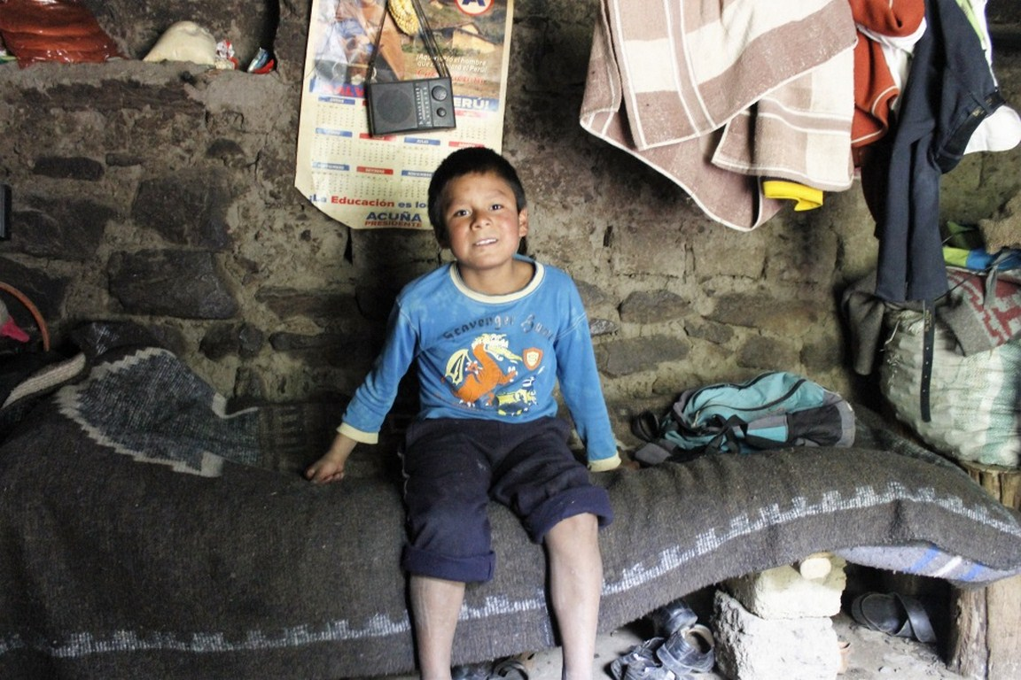
Elvis
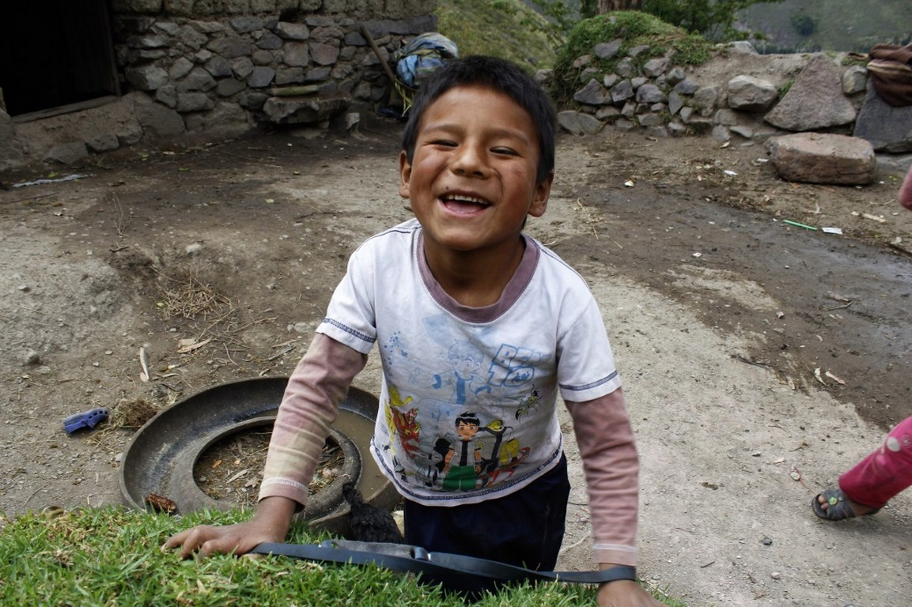
Tadeo

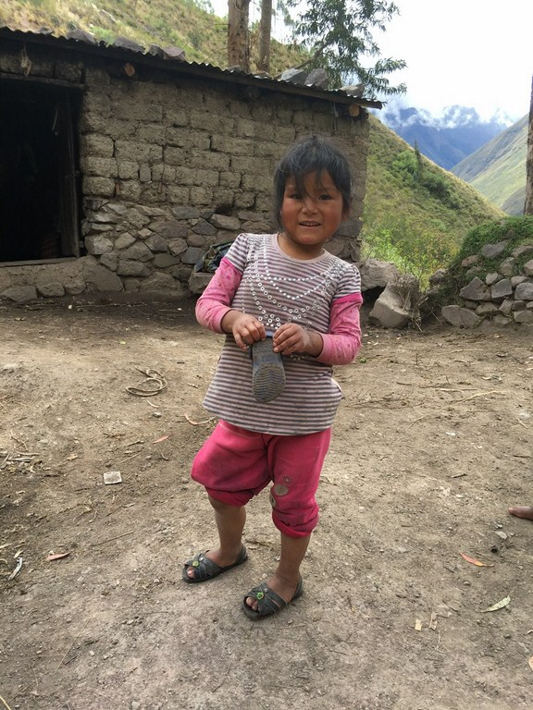
Virginia

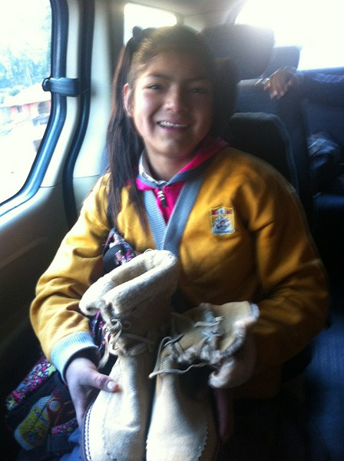
Silvia
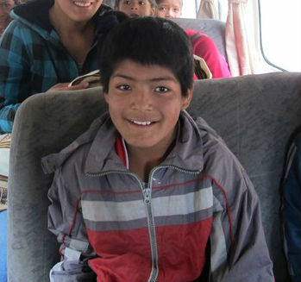
Raul
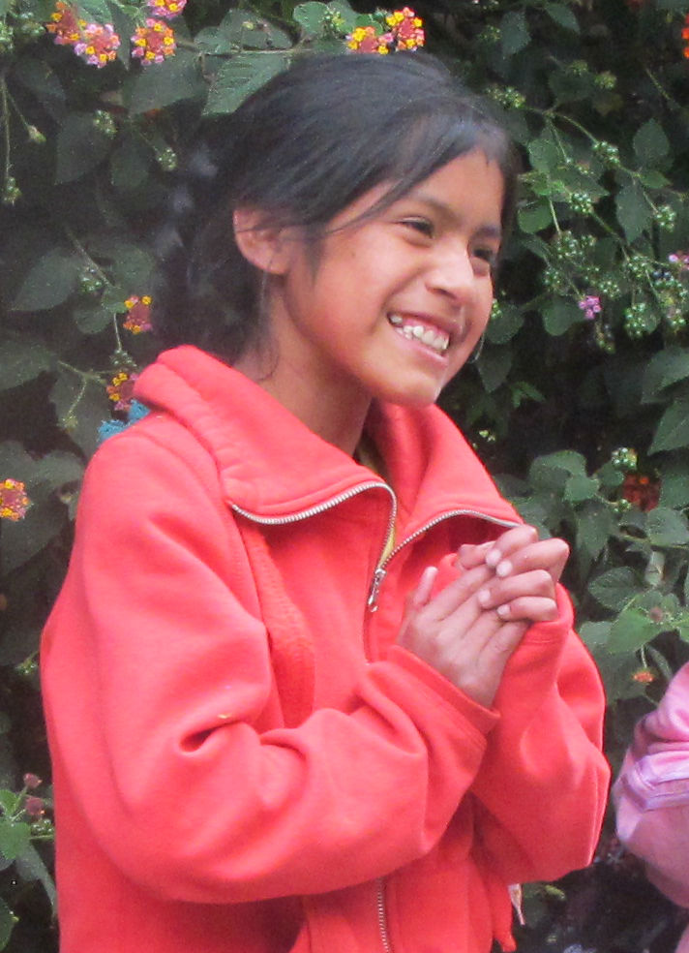
Rocio
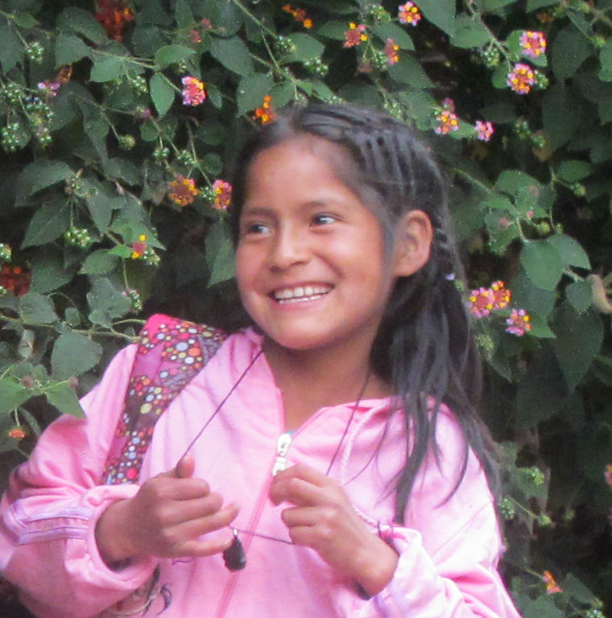
Luz Marina

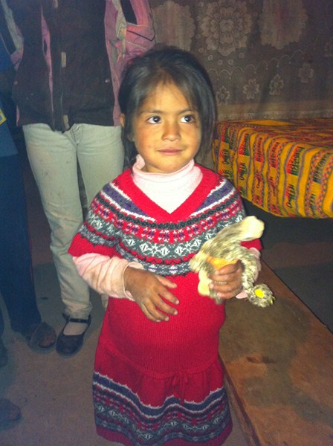
Veronica
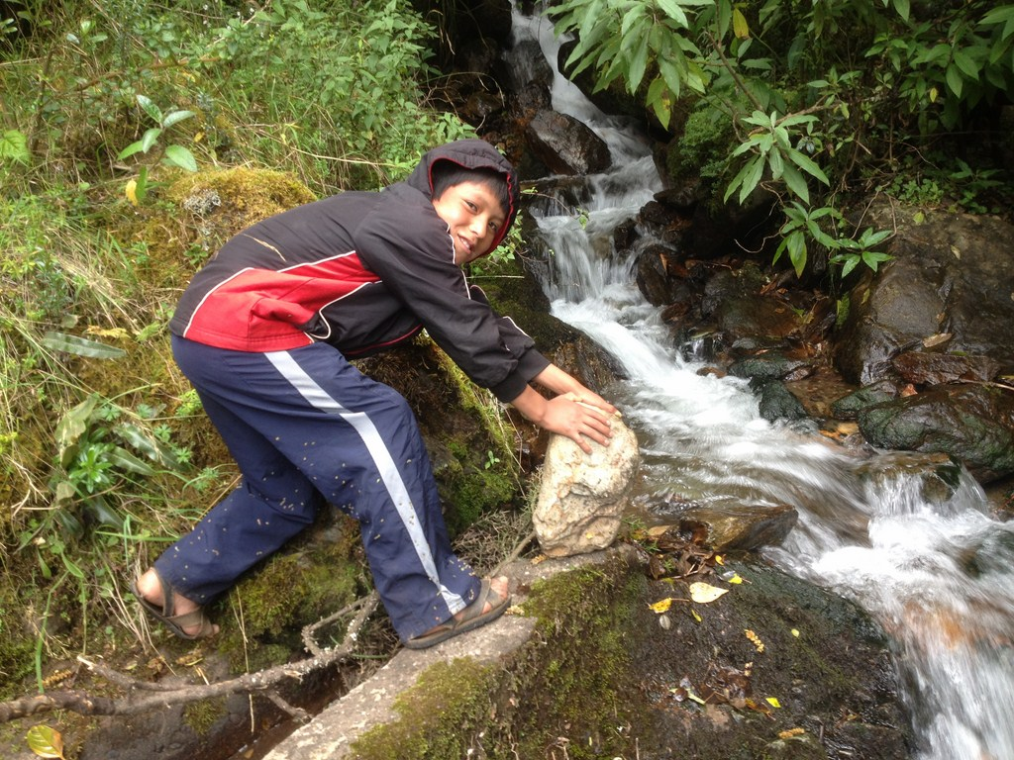

Elias
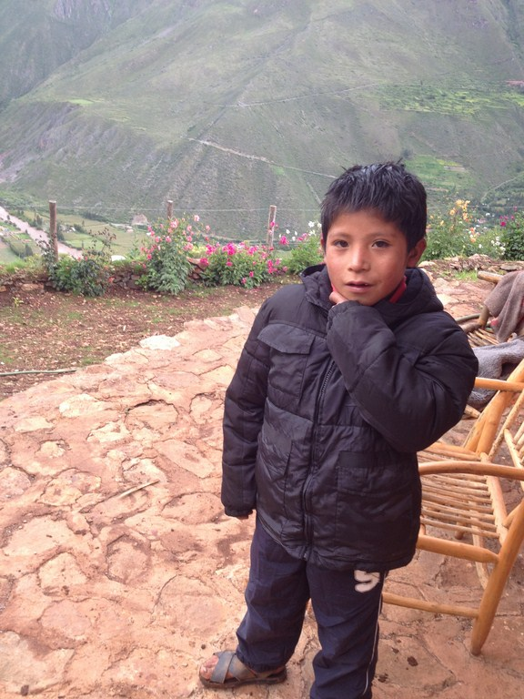

Hector
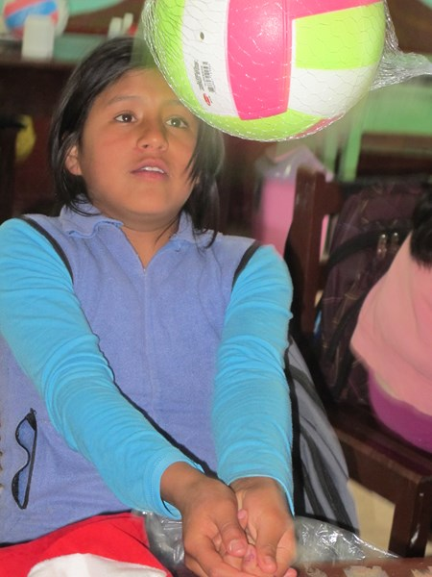
Libertad
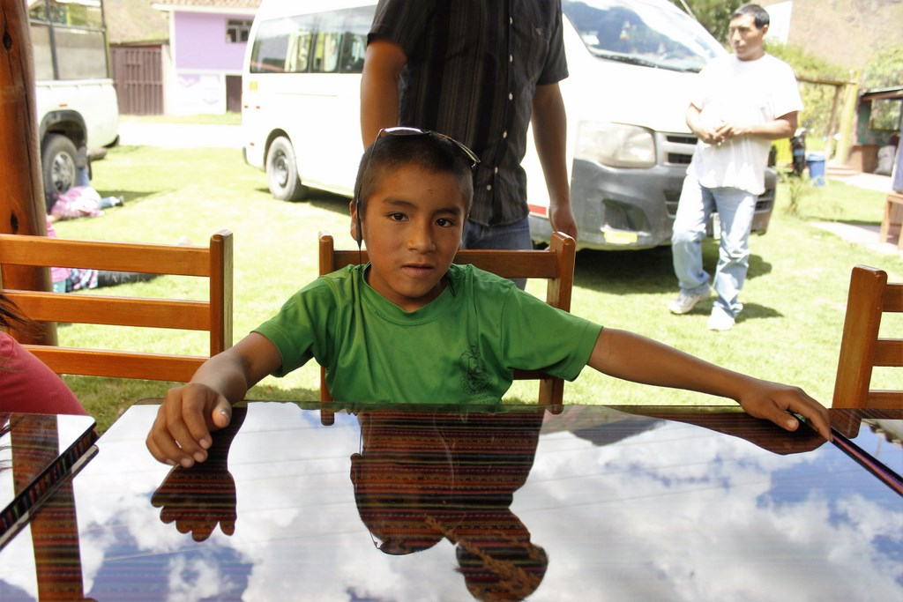
Franklin

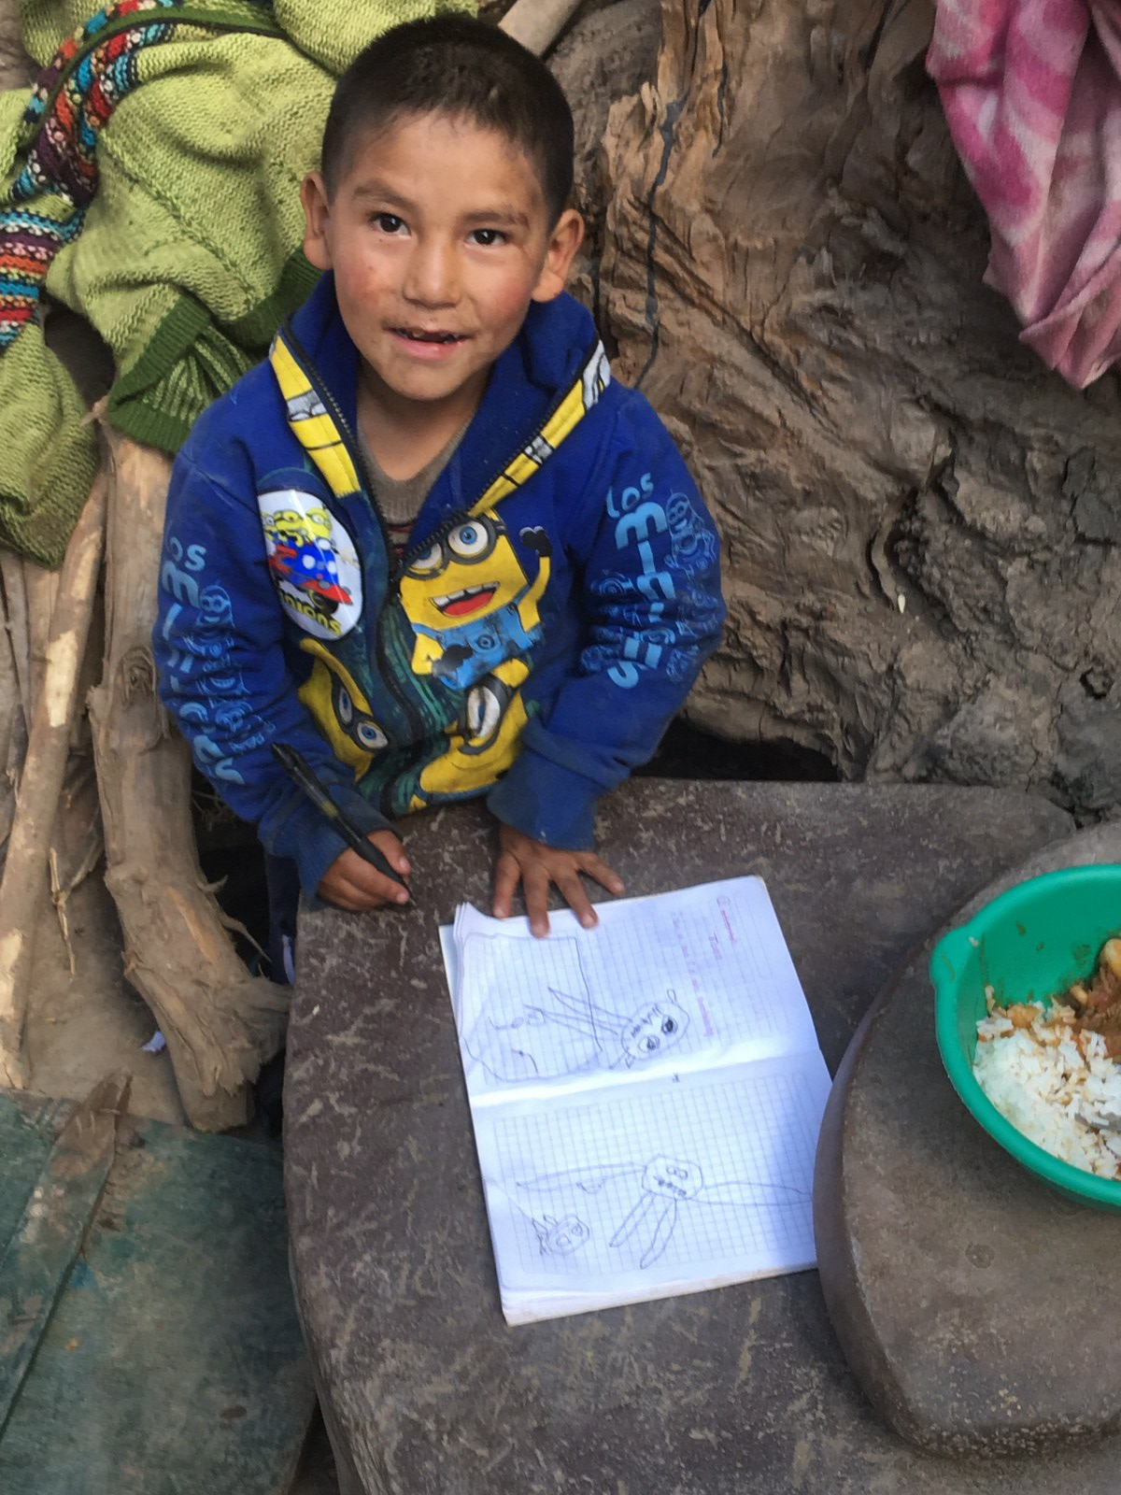
Diego

