School of Tastayoc

T’astayoc is one of the small villages in the mountains of Ollantaytambo in the sacred valley of Cusco. The ancestors of the people who live in those villages used to be the owners of the fertile lands of the sacred valley in Cusco. The sacred lands they lived on include Machupicchu, Ollantaytambo, Pisac, and Saqsayhuman.

When the conquerors came to the Andes, the native peoples lost their land and many of them ran away to the mountains to escape the violence and sickness that the conquerors brought to the land.

But even in losing their animals, land and homes, for some reason, they didn’t lose their happiness, friendship and their love for the Pachamama and the Apus (spirits of the mountains). Until today, the harsh living conditions where they can’t grow too much hasn’t changed them; they are still people who are alive. Maybe it is because of the beautiful land that they are living on which nurtures their behavior. The best part is when you visit them, you can clearly see what happy people they are and how they face life, with a smile and how much they thank God for every beautiful day they have.

Carlos and Alejandrah along with native people from the surrounding area, built a kitchen, dining room, a greenhouse, improve the bathrooms. It's such a delight to witness how happy and healthy the children have become in such a short time.

The greenhouses and medicinal herb gardens are flourishing. The Tastayoc children sang an extremely touching song about how we are all One, about the conditions on Patcha Mamma (Mother Earth) and how we must all join together to do our part. These children are in the middle of nowhere with no outside contact, no TV, and yet so conscious.

The first project for Paskay was set up in the community of T’astayoc in the high andes at an altitude of 4100m above sea level (located close to the Abra Malaga). This project is a food and nutrition project for the children of the community.

Carlos and Alejendra could see that there were many malnourished children studying at the school and the teacher told stories of children falling asleep in class as they were exhausted, unfit and unable to concentrate.

Paskay thanks to Alejandrah build a “comedor” as a place for the children to be able to eat their meals before having to embark on the journey home. Many of the children studying at the school have to walk over an hour to reach their homes even higher up in the mountains.

There are 16 children enrolled at the school and only one teacher and class room so the teacher teaches all different grades in one room. The children are first language Quechua speakers and the classes are taught in Spanish and Quechua so the children keep their ancient language and Spanish that is official language in Peru.

There has been a significant change in the health of the children since the food and nutrition program has been in place. It is now evident that most of the children are all above average weight and height.

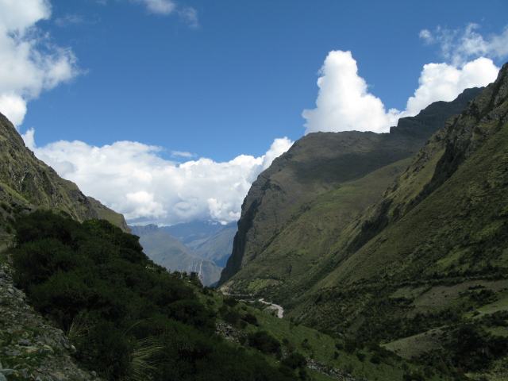

This is the little school. The red roof is our Kitchen and the plastic one is our greenhouse that was built with the support of my friend, Gisela.

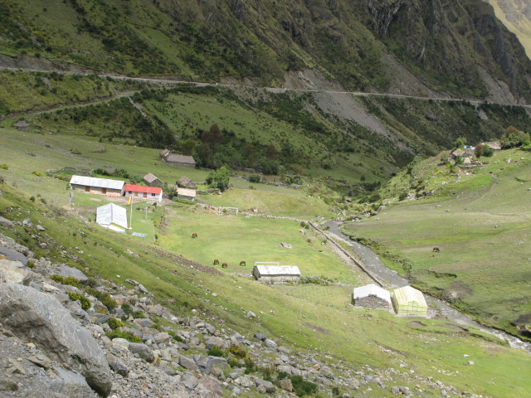

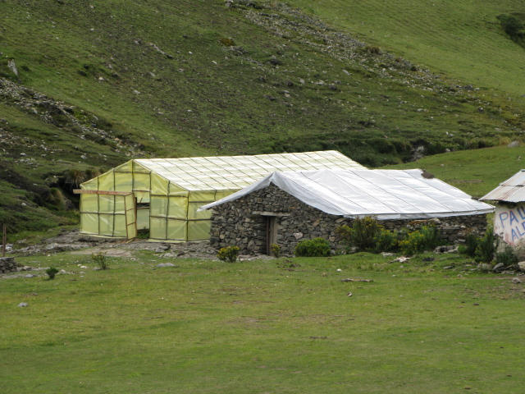

Lunch is prepared and cooked in the kichen for the students who spend three to four hours walking to the school every day. Vegetables are grown in our greenhouse.

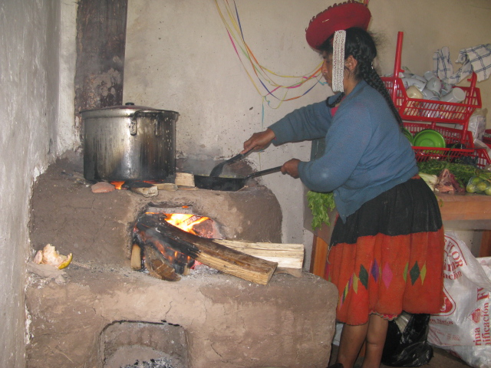

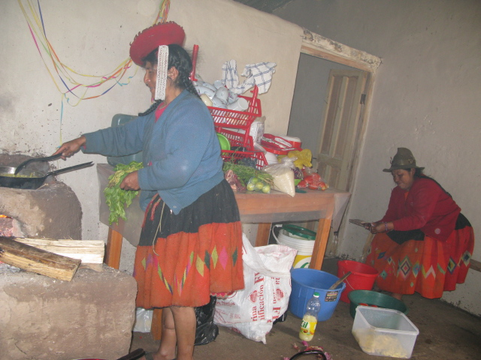
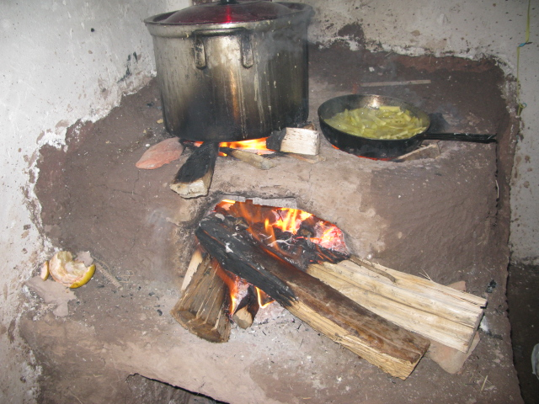

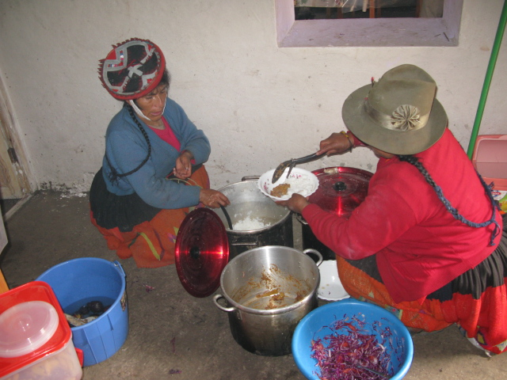

Kids having lunch at school. They obviously enjoy the food.

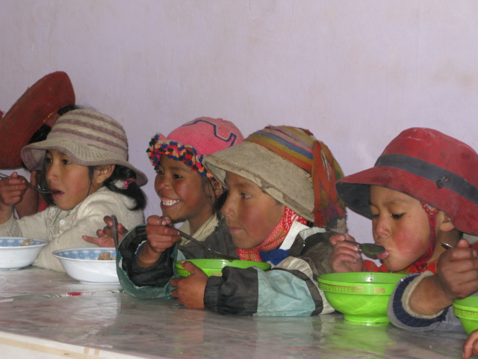

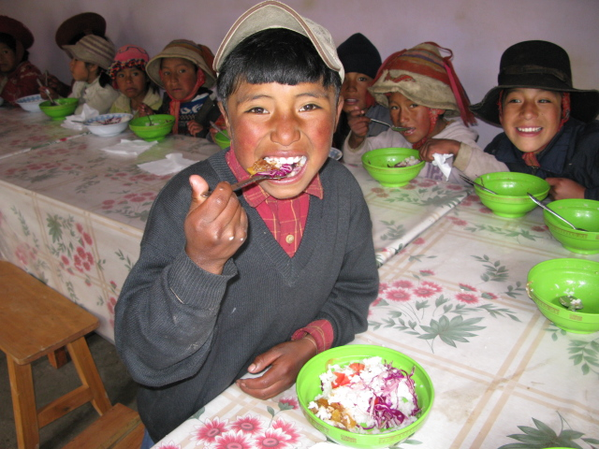
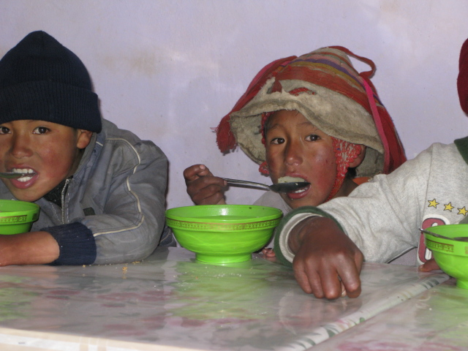

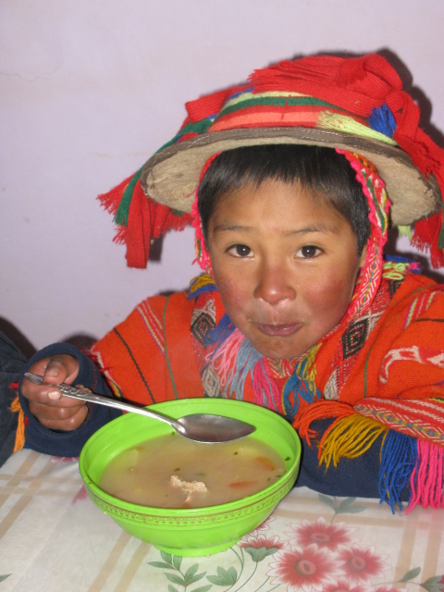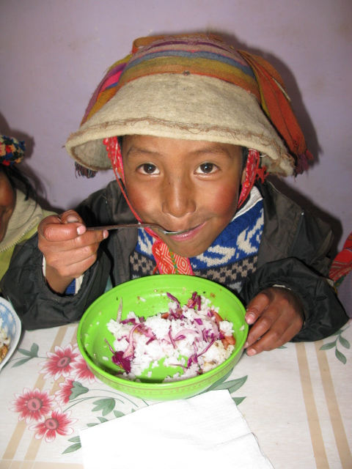

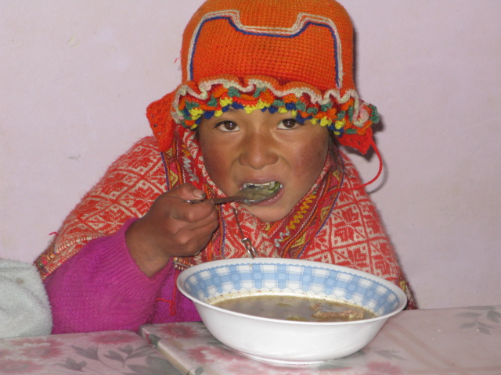

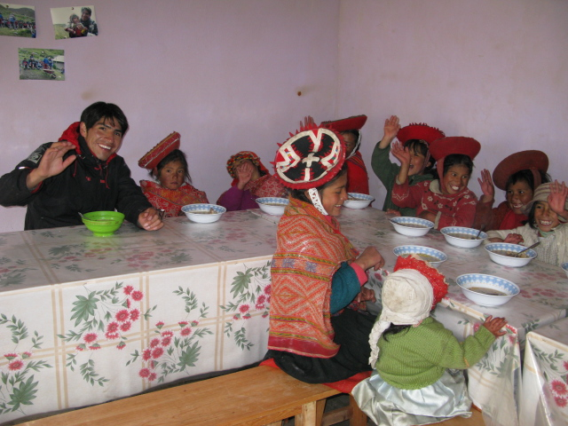

Learning in the classroom

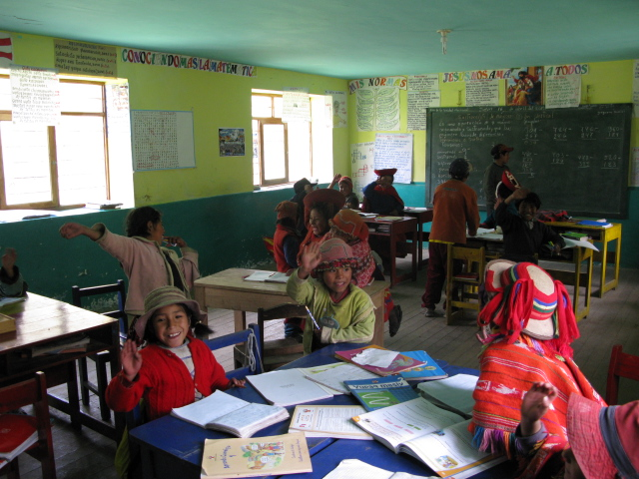

Playing on the school playground
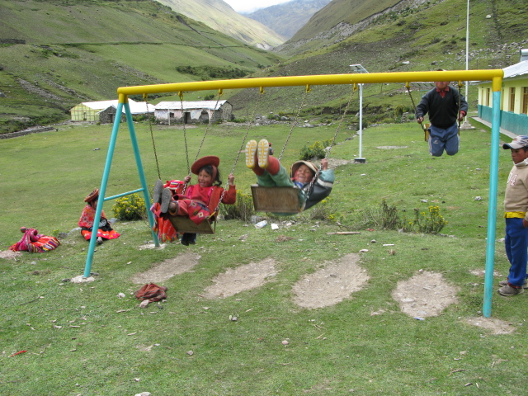

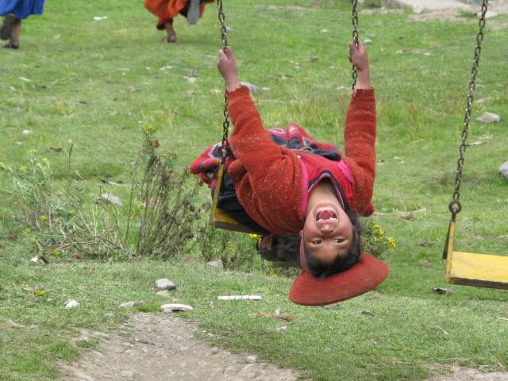

Beautiful Landscape

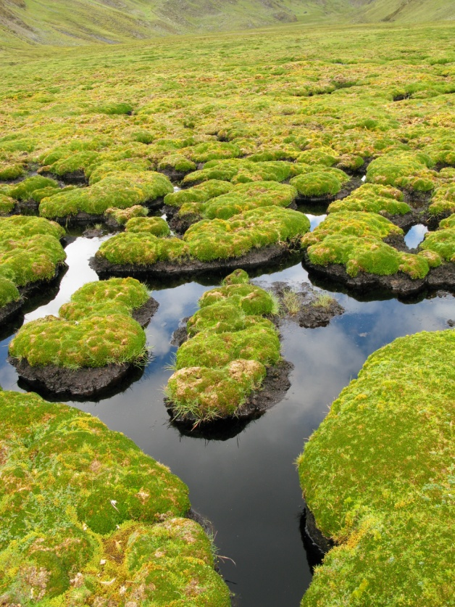

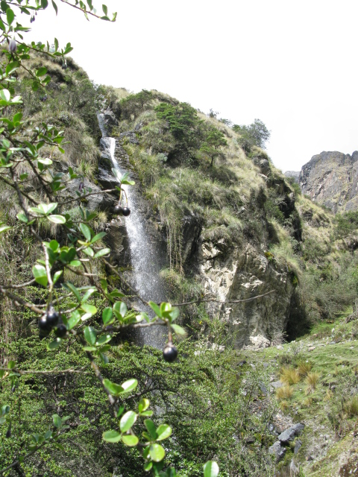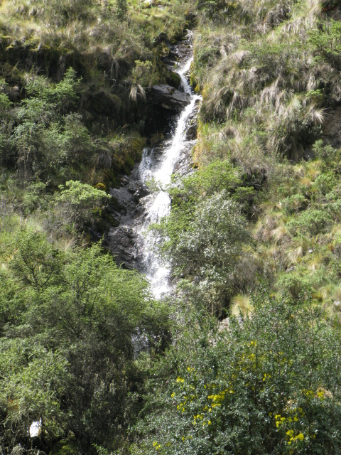

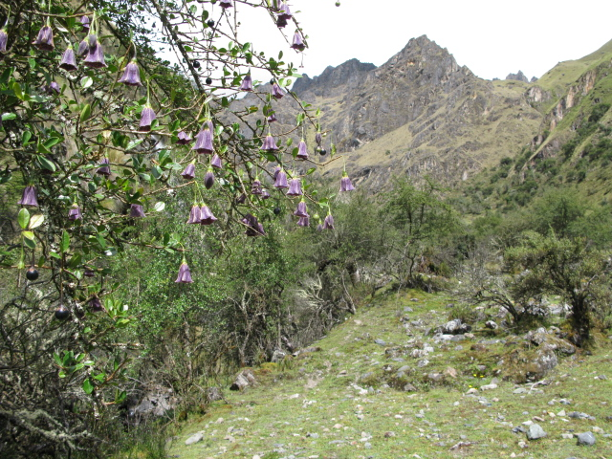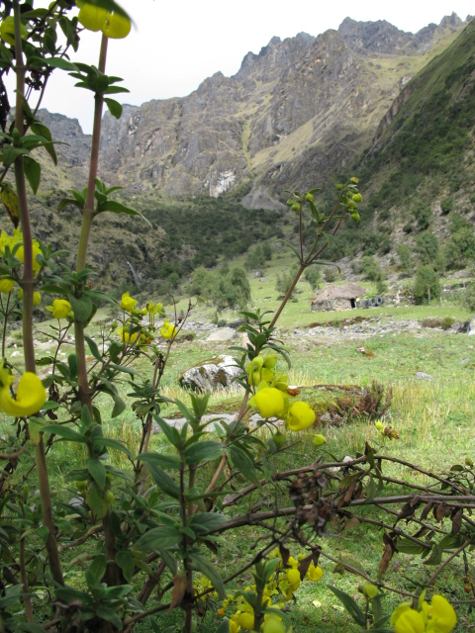

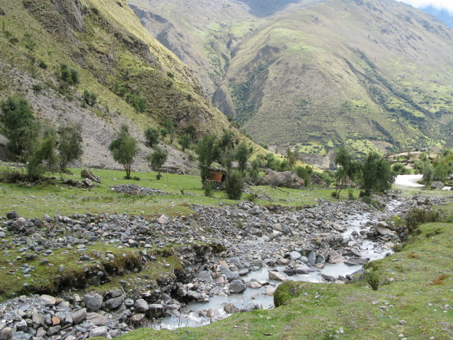

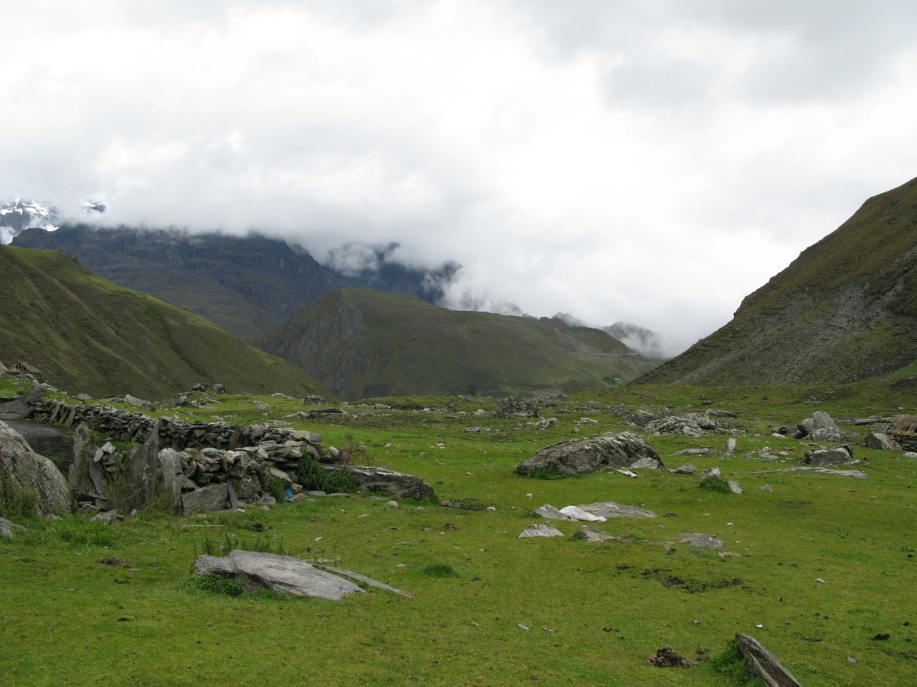

You are very welcome to visit our land, you will always find hugs, smile and friendship here.

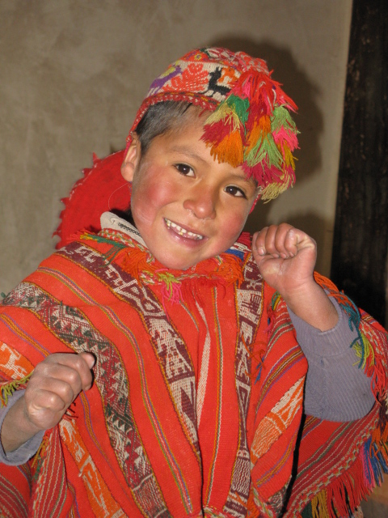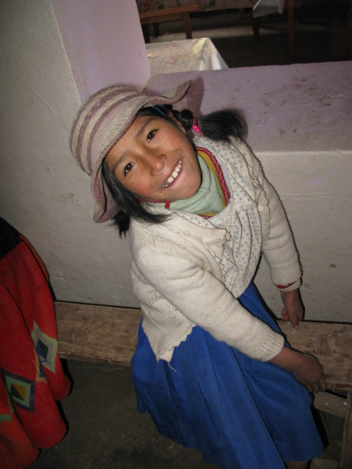

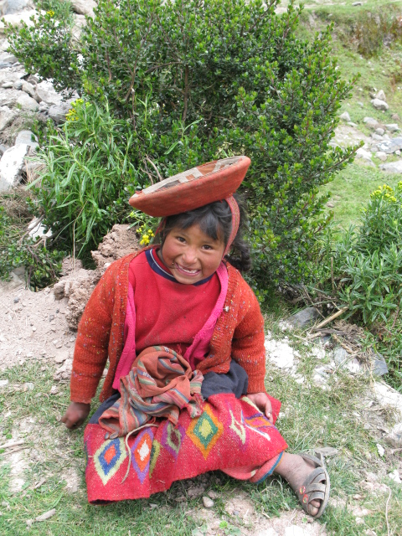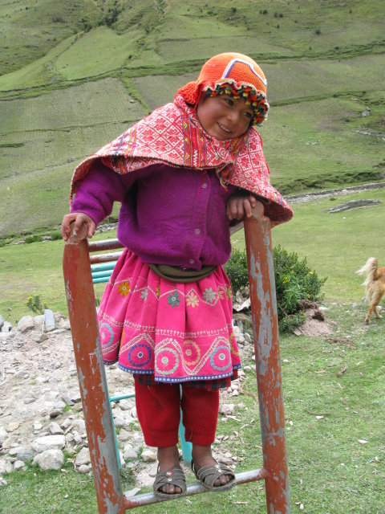

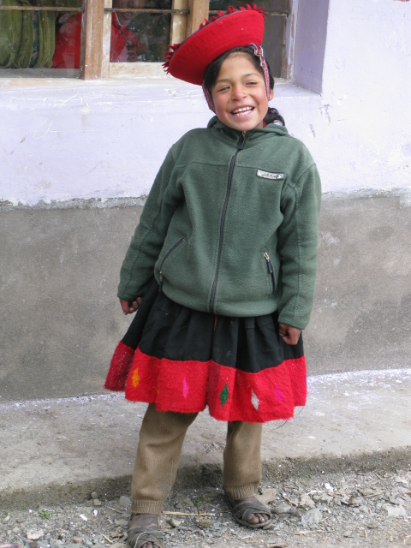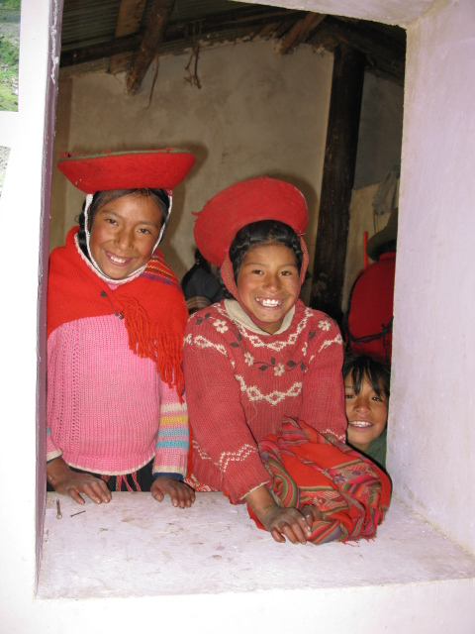

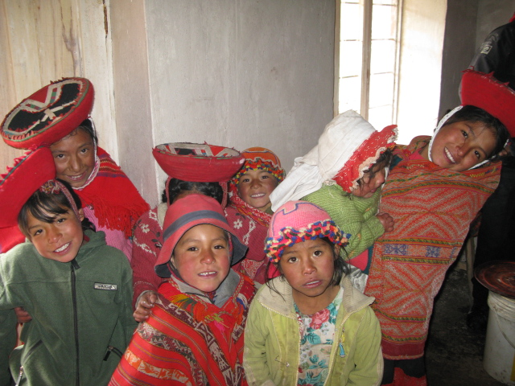
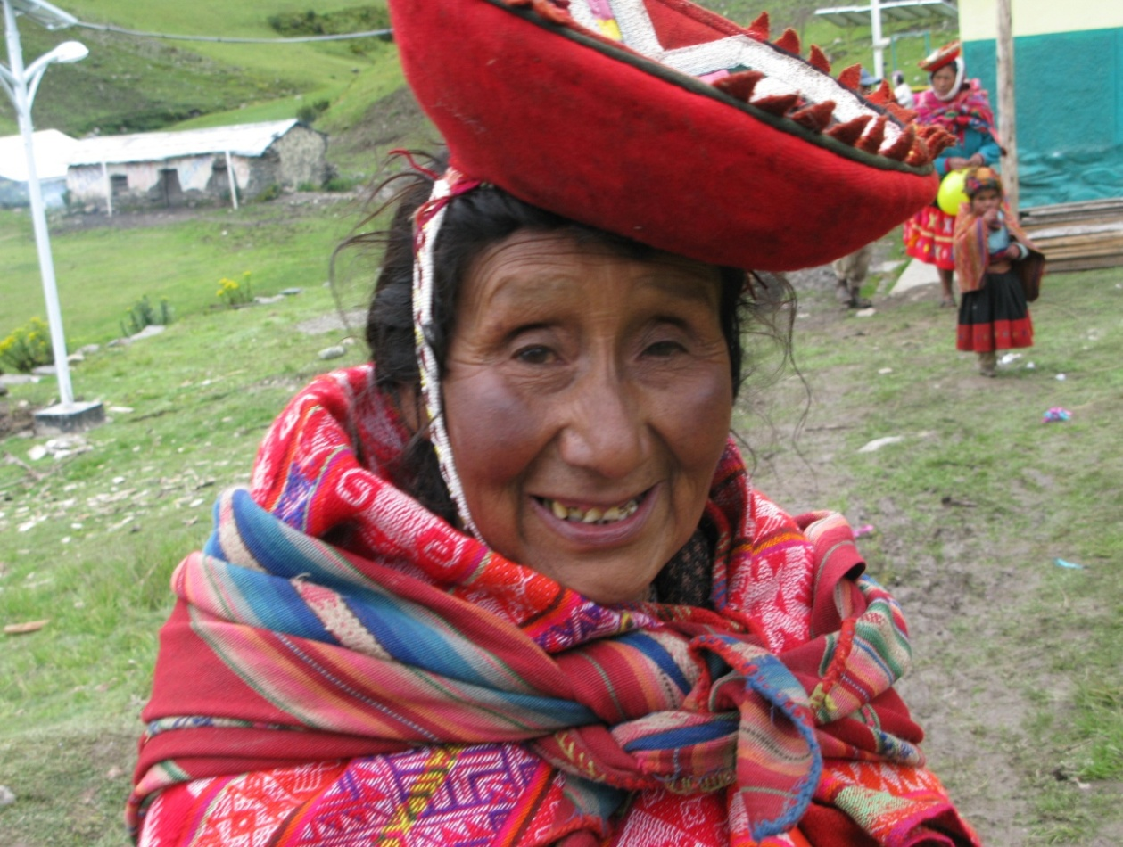

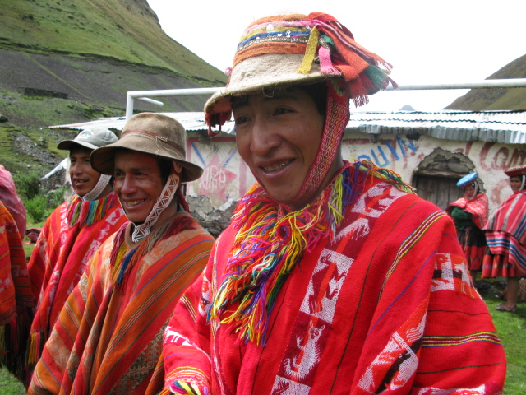

We look forward to seeing you!

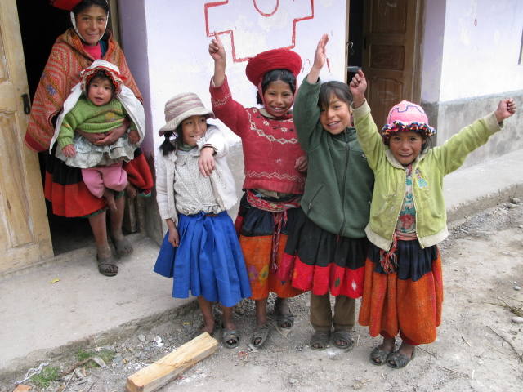

End

